**Math 120  
4.4 Exponential and Logarithmic Equations**

# **Objectives:**

1. Use like bases to solve exponential equations.
2. Use logarithms to solve exponential equations.
3. Use the definition of a logarithm to solve logarithmic equations.
4. Use the one-to-one property of logarithms to solve logarithmic equations.
5. Solve applied problems involving exponential and logarithmic equations.

# **Topic #1: Exponential Equations**

Exponential equations contain a variable in an exponent. There are different techniques to solve them.

***Solving with logarithms***

Consider the equation:

$$4^{x}=15$$

We use the power rule of logarithms by introducing a logarithm to both sides:

A graph confirms the decimal approximation:

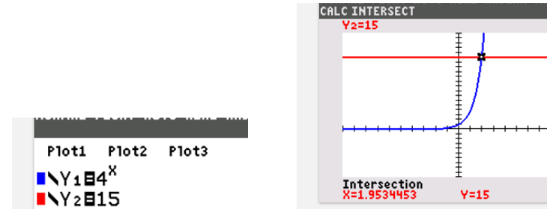

The second approach is more common. We could have introduced a common log (base $10$) instead and still have the correct answer. For consistency, the natural log will be used throughout.

Example #2 – Solve the Exponential Equation

a) $e^{x}=12.75$

Introduce the natural log to both sides (this undoes base $e$ on the left side):

b) $2e^{2x}=180$

Divide by 2 to Isolate the base, introduce the natural log to both sides:

c) ${17}^{x}=47$

Introduce the natural log to both sides and solve:

# **Topic #2: Logarithmic Equations**

Logarithmic equations contain a variable inside the logarithm. When solving these equations, we must check to see if the proposed solutions are in the domain (recall that logarithms only accept POSITIVE inputs). There are two basic techniques to solve them.

***Definition of Logarithm***

Consider the equation:

$$\log_{4}\left(x+3\right)=2$$

Before solving, we identify the domain:

Now we can apply the definition of logarithm:

The proposed solution is in the domain and is accepted! A graph confirms:

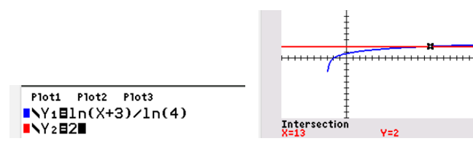

Example #1 – Solve the Logarithmic Equation

a) $\log_{2}\left(x+19\right)=8$

The domain is

apply the definition of logarithm:

The solution is in the domain and is accepted!

b) $\ln\left(6x\right)=10$

The domain is

apply the definition of logarithm (this is base $e$):

The solution is in the domain and is accepted!

c) $8+4\ln{x=6}$

The domain is

apply the definition:

***Like Base Property***

In some cases, logarithmic equations can be solved by using the **Like Base Property of Logarithms:**

*Example #2* – Solve the Logarithmic Equation

a) $3\log{x}=\log{125}$

The domain is __________________The property does not apply yet; apply the power rule to the left side:

The solution is in the domain and is accepted!

b) $2\log_{6}{x-\log_{6}{5=\log_{6}{405}}}$

The domain is ___________________The property does not apply yet; apply the power and quotient rule to the left side:

We cannot accept the solution _________________it is out of the domain! The only solution is ______________

c) $\ln\left(8x-7\right)=\ln\left(x+3\right)+\ln{9}$

The more restrictive domain is __________________The property does not apply yet; apply the product rule to the right side:

We cannot accept the proposed solution, it is out of the domain! There is ______________________

d) Consider the equation:

$$\ln\left(x+2\right)+\ln\left(x\right)=\ln{8}$$

Before solving, identify the domain. The first term indicates a domain $__________________$ and the second term indicates a domain $__________________$ we pick the MORE restrictive of the two:

The property does not apply yet, the left side can be combined into a single logarithm by the product rule:

The bases now cancel, leaving the quadratic equation:

We cannot accept the solution ____________it is out of the domain! The only solution is ________________

# **Topic #3: Application of Logarithmic and Exponential Equations**

Both types of functions are used to model real life situations

*Example #1* – Exponential Model

The population of a small country over time is modeled by the function

$$y=18.1e^{0.0133t}$$

where $y$ is the population in millions and $t$ is the number of years after 2010.

a) What was the population in 2010?

b) When will the population reach 24.3 million? Round to the nearest year.

c) When will the population double? Round to the nearest year.

The initial population is $y_{o}=18.1$, double the initial population gives $y=2*18.1→y=36.2$ and gives the equation:

When we isolate the base, we get the equation:

The model tells us the population will double i**n ______________________________**

We can also graph to solve either of the equations above:

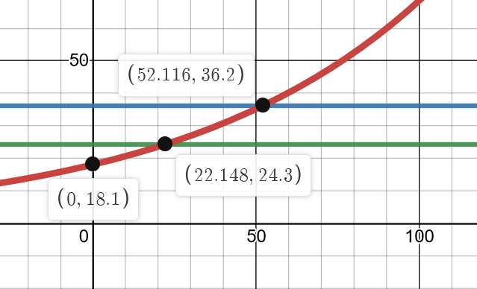

*Example #1* – Logarithmic Model

The percentage of students in a class who can recall important features of a classroom lecture over time is modeled by the function

$$y=95-30\log_{2}{x};\text{for }1≤x≤9$$

where $y$ is the percentage of students and $x$ is the number of days after the lecture.

a) What percentage of the students will recall important features $1$ day after a lecture?

b) After how many days will only half the students recall important information?

Half of the class is $y=50\%$, giving the equation:

We can also graph to see the point of intersection that solves the equation:

